**GEOS3102: Global Energy & Resources Labs**

Dietmar Muller, Tristan Salles, Amy I’Anson

Lab Overview

|  |  |  |  |  |
| --- | --- | --- | --- | --- |
|  | **Exercises** | **Weight** | **Due Date** | **Submission** |
| Lab 1 (Week 8) | Intro to Global Petroleum Resources and iPython | 10% | Thursday May 11 @ 9am | Madsen Dropbox |
| Lab 2  (Week 9) | Badlands | 15% | Thursday May 18 @ 9am | Madsen Dropbox |
| Lab 3 (Week 10) | Seismic Reflection Surveys | 15% | Thursday May 25 @ 9am | Madsen Dropbox |
| Lab 4 (Week 11) | Well Log Analysis | 15% | Thursday June 1 @ 9am | Madsen Dropbox |
| Lab 5  (Week 12) | Arafura Basin Petroleum Systems | 15% | Thursday June 8 @ 9am | Madsen Dropbox |
| Lab 6  (Week 13) | Tectonic Subsidence and Arafura Basin Report | 30% | Thursday June 15 @ 9am | Email [amy.ianson@sydney.edu.au](mailto:amy.ianson@sydney.edu.au) |

Each week a paper copy of the exercise will be provided for you. Please write neatly and clearly, messy and illegible reports will not be marked. You are also welcome to complete the exercise in the pdf available online. Remember to attach relevant maps and data.

Exercises are shown in grey boxes, answer in the space provided or attach your answer to the lab sheet.

**Your assignment is due Thursday the following week at 9am! 10% will be deducted per day late.**

Please note: You do not need to include your script for iPython practicals unless a question states “**Include your script”** in which case you only need to include the relevant portion of your script (please do not waste paper and print the entire script).

Lab 3: Seismic Reflection Surveys

This lab is divided into two parts, the first part is designed to familiarize you with the basic concepts of seismic data using iPython and the second will involve the interpretation of 6 seismic lines from the Cooper Basin in Australia. You must hand in (in the following order);

* Part 1 answer sheet & Part 2 answer sheet
* Basemap showing the location of the Yanko Fault
* Your six interpreted seismic lines (**In order:** 93-ECJ, 92-DSM, 88FHY, 92-DLK, 89-GAG, 77-JHC)
* Synthetic seismogram from Genoa 1 with your three seismic horizons marked on the borehole track

Reflection seismology (or seismic reflection) is a method of exploration geophysics that uses the principles of seismology to estimate the properties of the Earth's subsurface from reflected seismic waves. The method requires a controlled seismic source of energy, such as dynamite/Tovex, a specialized air gun or a seismic vibrator, commonly known by the trademark name Vibroseis.

Seismic reflection surveys are a key tool used in the hydrocarbon and minerals industry to interpret the subsurface. The basic seismic signal results in changes in acoustic impedance (density x velocity). Different rocks have different densities and this generally corresponds to increasing velocity.

**Some typical rock parameters;**

* Basalt: v =5500m/s & density = 2.9g/cc
* Limestone: v =6000m/s & density = 2.5g/cc
* Sandstone: v =3700m/s & density = 2.5g/cc
* Shale: v =3200m/s & density = 2.4g/cc
* Coal: v =2000m/s & density = 1.5g/cc
* Water: v =1500m/s & density = 1g/cc
* Air: v =300m/s & density = 0.0012g/cc

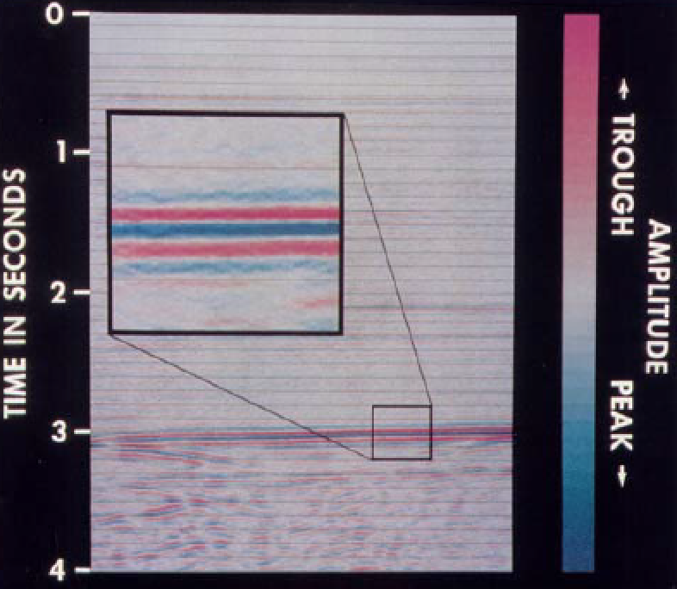For a normal incidence reflection (perpendicular ray path between source-receiver and reflector), the reflection coefficient (RC) records the strength (0-1) and polarity (positive or negative) of a reflection, given by;

We can then display peaks and troughs in RC as peaks and troughs, various colour scales are used. The ‘image’ results from seismic wave propogation through a diverse medium.

Seismic data are based on TWT (two way travel time), we may later convert the data to depth, but this relies on good velocity information.

When we interpret seismic data, we want to trace the same geological boundary and/or packages over great distances. To help us do that, while minimizing misties, we define the geological boundary and internal bedform characteristics as shown below – and be sure to ‘pick’ the same seismic character as we move through the survey.

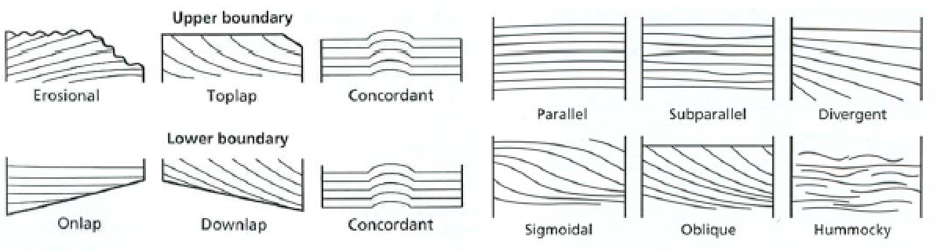

The interpretation of seismic data is an iterative process of;

1. Fault interpretation
2. Horizon interpretation
3. Well-ties
4. Contour maps and isochrons

A basic interpretation procedure on 2D vintage lines such as in this exercise is as follows. **Follow this procedure for part 2 of this Lab.**

Review all the lines first and use the base map to work out the orientation of the lines. The SP (shot point) numbering convention is used, the line name is near the top of the section, above that are the intersections.

1. Start by interpreting any faults on the 2D lines. 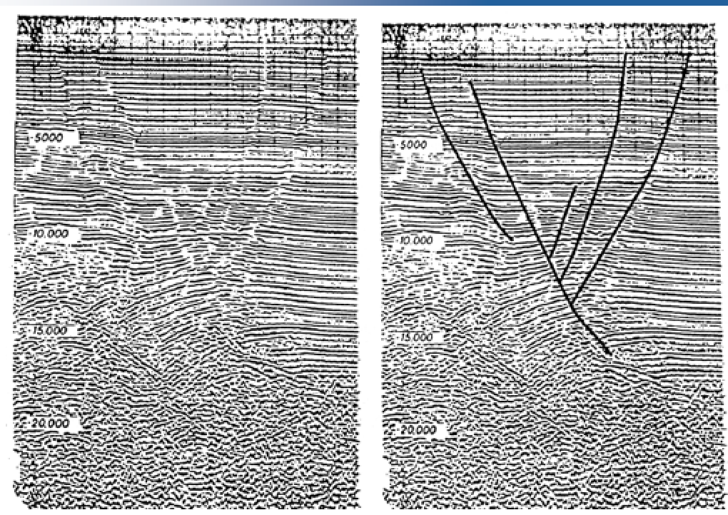
2. Trace reflecting surfaces (horizons) on one line. Start with a continuous, high amplitude reflection event. Trace 2 high amplitude, continuous reflectors. Also, trace 2 low amplitude and/or discontinuous reflection events

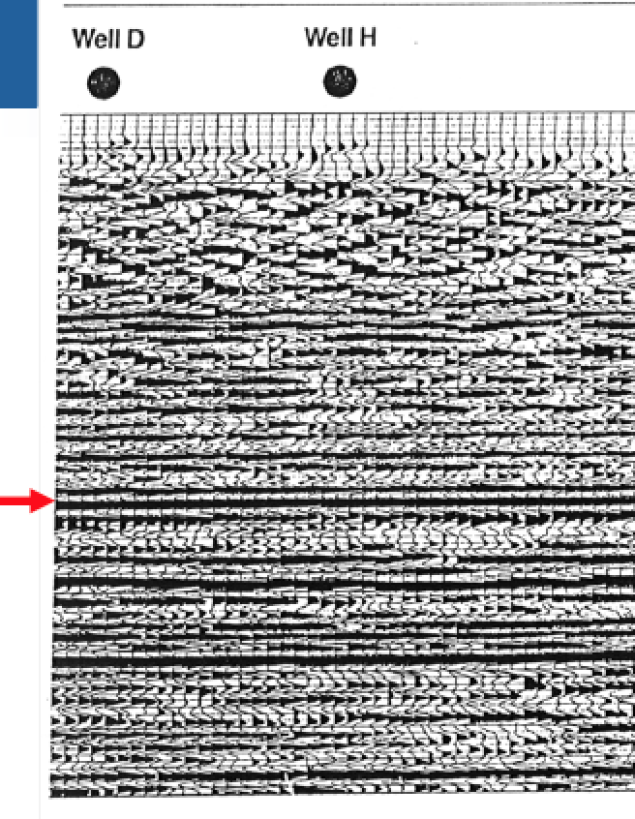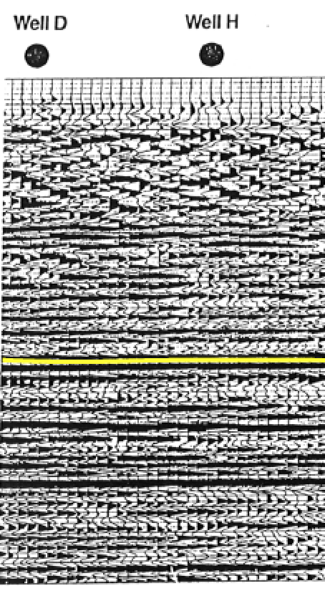

1. Transfer fault and horizon picks to crossing lines by folding the paper at line intersections. Line intersections are shown on your basemap and can be deciphered through shot-point numbers.

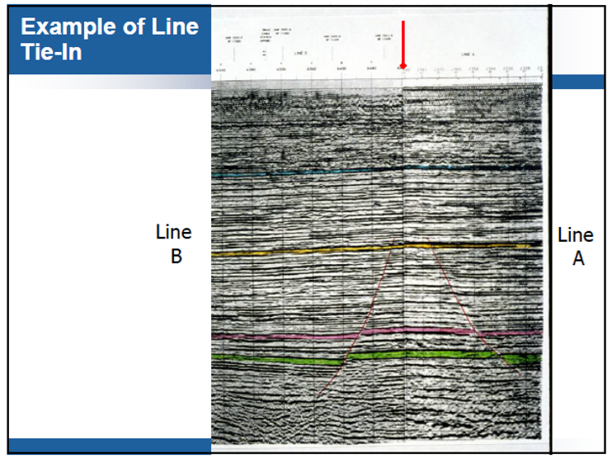

Once we have interpreted horizons, we would plot values (TWT) on a basemap and make time structure maps. We can also make thickness isochrons in the same way. This is usually done with computer programs and we will not be generating maps in this exercise. However, it is an important part of the interpretation process.

Part 1: Introductory Exercises

NAME: _________________________________ SID: ________________________________

Q1. Start with equal density (rho1=rho2=rho3) for all 3 layers and adjust the velocity (v1, v2, v3) of the layers. What is required to have two reflection coefficients of opposite sign?

________________________________________________________________________________________________________________________________________________________________________________________________________________________________________________________________________________________________________________________________________________________________________

Q2. Create a simple three layered model as shown below. What reflection coefficients would you get between the layers.

_______________________________________________________________________

_______________________________________________________________________

_______________________________________________________________________

_______________________________________________________________________

Q3. Create a model where the layers have different densities but reflection event occurs. Include this image. Add a label to your figure. Explains why there is no reflection and how this should be factored in your interpretation.

____________________________________________________________________________________________________________________________________________________________________________________________________________________________________________________________________________________________________________________________________________________________________________________________________________________________________________________________________________________________________________________________________________________________

Q4. Seismic sections are in TIME, we convert to DEPTH through a velocity model (in this case, vice-versa), this process has the potential to introduce errors. However, is a useful step if we are mapping geological surfaces. We require a T-D chart. What does the various slopes in the T-D chart provided correspond to?

________________________________________________________________________________________________________________________________________________________________________________________________________________________________________________________________________________________________________________________________________________________________________

Q5. Define a fixed geological model as per Q2. Adjust the parameters of the source wavelet to get a clean seismogram. What is the effect of wavelet frequency and amplitude on the seismogram?

____________________________________________________________________________________________________________________________________________________________________________________________________________________________________________________________________________________________________________________________________________________________________________________________________________________________________________________________________________________________________________________________________________________________

Q6. Define a second geological model as per Question 5, except replace sandstone with limestone. What is the difference in the resultant seismogram, if you keep the source wavelet constant?

__________________________________________________________________________________________________________________________________________________________________________________________________________________________________________________________________________________________________________________________________________________________________________________________________________________________________________________________________

Part 2: Interpretation Exercise

Q1. When interpreting seismic data we generally start from the top of the section and work down. Explain why.

________________________________________________________________________________________________________________________________________________________________________________________________________________________________________________________________________________________________________________________________________

Q2. Notice that the 1977 line has not been reprocessed, it was considered good quality at the time. Compare the SP spacing and vertical resolution of the old with the new. What is the difference, why?

________________________________________________________________________________________________________________________________________________________________________________________________________________________________________________________________________________________________________________________________________

Q3. Once you have mapped your horizons across all lines as per the instructions on page 3/4, use the provided synthetic seismogram from Genoa 1, to determine the stratigraphic horizon associated with your interpreted reflectors. Give each reflector an appropriate name, draw a key for your seismic lines below.

Q4. Characterise the seismic reflection character of the Cadna-Owie formation, as per the terminology provided.

__________________________________________________________________________________________________________________________________________________________________________________________________________________________________________________________________________________________________________________________________________________________________________________________________________________________

Q5. Interpret the location of the Yanko Fault in the north of the study area. Show the fault trace on your map.

Q6: Calculate the throw of the fault assuming the average velocity of the overlying sediments is 3000m/sec. This is a typical velocity used for Jurassic-Permian aged sediments in Eastern Australian basins during a first pass analysis.

Q7. At what depth, would you intersect the top of the Toolachee formation at Genoa North 1?

________________________________________________________________________________________________________________________________________________________________________________________________________________________________________________________________________________________________________________________________________